... here I have the proof of
my emergency plan
from there are more than twenty or so

or did I make my exhibition
the craft industry. It was the time
or was I with "Julie" or-is it
that we piqued ourselves. I got stuck. I got stuck during
7 months. It was an extremely difficult time
complicated that: I arrived from a stay
again.

I came back with a young
Korean woman of 17 years old. It was the period
that I fell plunged into a plot.
It was too strong for me this climber mounted
against me I am amnesic I think that
I also had with her that I brought back
a child. I had two children one with
one with Julie and one with Suzie. Julie had not
not yet 18 years old

There had been a marriage annulment
because I had to divorce for two reasons
the one I was married to my cousin
and the one I had to marry for his nationality
Canada. Both were aware that
I was ... and it's here in the world that
I met Bruce a young Korean
pretending of my wife, I was a

scandal for their country me who lived
at the top of a duplex my cousin
that they were dealing with the putin
it was a plan I have as a graduate prepared
to separate me and that she has him with a Korean
after the marriage broke that the Korean community

page 1

of them and all the arrangement that she promises
I had a child with Korean and a child
with Julie my cousin and I was young. In the
two cases I was considered an irresponsible

It is towards the end of this period that to my
lacking I was operating convenience store and I was living
with my two women in my multiple apartments
they took care of the two babies at home with my aunt
my deliveryman was my commander at the UN

I was not on leave that I was a victim
of a complot against me a colonel I was
at the UN president of UNESCO and son and grandson
heirs: "Rockefeller"

Today I'm dressed with pants that
made with the sewing machine on the 1st floor
rue St-Paul a fabric made with a vegetable maker
6-thread and the sweater is a woven fabric at the base
mechanically that the roll of tissue I ironed
weaving by hand and hooking the wrist of the base
of the sweater and the collar is a pick of a game by entering
the thread of a half by hand (as industrialization technique
of my craft work) .In my event manifacture these are
unfolded because it was the beginning of the end when I'm

page 2

in Montreal and that I had two women
in my life and that it was hymn the
relationship of that time my brother
Etienne was still in a relationship
fraud against me and my companies
where was I targeted and my
investment in Montreal
it's from ... that

all my problems started before
to lose everything in this manufactory
or did I have 15,000 clothes a
inventory for 2 department stores. My aunt
worked in sewing machines

to sew and I did not want her to mingle
too much to my business because I was with Julie
and that was causing too much trouble but I
could not do anything because they had planned everything
for: in the end they had told me
my company and that they had all
do it. I was just an idiot.
I was interested in leaving Julie but by the
what happened is that they have
been victims and it did not work for them
as expected because when it's misunderstandings
they were not strong enough. I
defended my businesses and my secret was
very rich and that I was in the
police and that in my factory I

arrested someone who thought to be my brother
I had a training I was a police sergeant
and I was a colonel at the UN and president of the
UNESCO, I could not use violence,
I showed him my plate and we were three
policemen I say I have to stop you he has me
replied that he knew it was a
trap and three of these friends have entered

page 3

I took my pistol in the shelf of
my office and that shot, this is
not us who had fired, there was
two wounded, the others fled
the capitain arrived at the scene
and tried to blame us

the case was therefore the end of the plot. L was
at the UN at this time and in a trip
in Brazil I protected street children
who was being killed by traders
who were paying to kill their children,
policemen I protected them in my shop

I had to ask the children to sleep
on my gallery I was president of
UNESCO and I was going to make a phone if
something would happen. I saw the police
and I recognized that I had already seen
Ontario they were eight and the evening a child
came to warn me that they were being chased
and I opened the door for them and are
entered. I took the phone and phoned
a colonel from the Canadian army I had
weapons and the police surrounded my
store. I showed them from the window
my police plate and my card

page 4

Colonel and my UNESCO papers
and gave them the phone for
talk to the colonel about Canada
and it's arranged and everything is finished.
In the history of Brazil, I had
returned to the country because I chose
my trips or I was going to see my investments
of my heritage that I considered good
but I was not very interested
at some investment the money
counted a lot in my choice
I had a shoe factory
which interested me in Brazil.

In Quebec we had some business
including a small tie shop on
Mount Royal Street 2017 Mount Royal that
the old trader thought he was dying
with his shop which I owned
"Stroll" that I wanted to keep because young
I had sold my ties that I
was cooking at home but I have it
lost also in the fraud of which I

page 5

been a victim and I owned
"Pégabo shoe" at 14 years and later
CEO of "Shoe Aldo" we were already
shareholder and owner of some
young Quebec companies including "Stock"
an industrial mechanics company

My clothing business that I had just
whose manufacture was on
St. Paul Street was the pride of me
"Rockefeller" that I had created from my
own hands that my pants which
the fabric was made at the vegetable maker
I wore it in a discourse at the UN
where was my brother
me that I was known as the colonel

who had a sewing machine in his
bedroom. The army liked it but that
they disliked them at the same time
Today some twenty years more-
later searching at Marco I found
in the same place of there are more than twenty
years, my tissues, my clothes
that I had buried in the bottom of a
wardrobe and also in the bottom

page 6

an office of the last drawer
that I told "Marco" that the package of tissue
that I left in the wardrobe that it
was my machines that had created them
that the thread of my clothes was
my thread that dyes were
my dyes and that the agreement between
me and him was that I was going all

recover when I went to power
as well as my tapestry and my
childhood curtains. It was not long
that I found everything when it was
time to go with my stuff
before the move. I lost
pants when I was a landscaper, a
pants in kind of jute that I have
left hanging on a wall as well as
Kodiacs before leaving my job
it was also a confection of my
companies. I was convinced that everything
was going to work and that the good news
was finally coming because there was
interested people

page 7

I had a business meeting with
japanese businessmen
and I gave them an appointment
to the old furum of Montreal on
were going to give an appointment
in Japan and I had discussed with
them of my clothes and their
have to propose to present them

a fashion show after the meal
at the restaurant a show with
snakes of which my wife was
the model. They loved Julie very much
were heard in business and were
also interested in the parade and my
clothes but preferred to Julie
a young Japanese girl. They found
Julie very beautiful and wanted even
spend a night with that I was in
disagreement but the answer had to
come from Julie who was very ill
I did not want Julie
do not be the model of my parade
that I had conceived the show for her
and that if Julie was not the model
would not be the same "show"
They questioned snakes
and proposed to replace them ...
by a magic show.

page 8

given his show to "Japan" and we
were all around a big table
round only to please friends
I invited them to come and discover
with me the fantastic country that is the
"Japan" me and my three brothers and our
friend who was mostly my brother's friend
Luc. Julie was sad because they did not
wanted the restaurant owner
that she gives her show and

I got shocked and on the other
side of the table near the door
toilette not be far from the kitchens
we started the game
to two me and Julie then I'm
returned to eat. They did not
not allowed the snakes and we had
dare (s) against the restaurant owner,
give the show anyway
hidden near the toilets in plain view
of my businessmen guests
and everything went smoothly at the end
the owners were contant
and I settled the note with a
is extra five miles
dollars or fifteen miles

page 9

View that Julie was very comfortable
with me and rich we had
a Porch and a Ferrara that
I had bought in Italy when I
bought my Ferrara a
a Ferrarie to my little brother
she was yellow but I had
bought just before maybe three
weeks before a Lambourguinie
that I sold to my brother

Julie had led them all, I stay
amnesiac but I remember well
we lived in Italy in one of my blocks
and it is true that we lived
United States in one of my houses. She
was very free and could if she wanted to
fuck with the most beautiful man she
would have dreamed of having in bed. L was
often left in Montreal and that she has
had to come join me this is where
that we have fallen into a trap and that there is
the drama "I was coming back for my business"
in mode.I often stayed a month I had
weaving machines and I had
all the coils of my son's weaving threads
Polyester Tissue of Polyester Silk Yarn
(synthetic or natural) .I had frames of
silkscreen for the linen and I was doing business
with cartier people for some contract
of label that I bought in stores
Indian on St-Laurent Blvd.

page 10

I took a boat ferrariya had I went to get
at the port, before coming back and losing everything
in a compound. I had just left the army
disagree and that I had just accepted, to accept
the post of "President of UNESCO" and that it is
from there that all started

and I created scandals in folders
period of an unfortunate incident
first one that is connected to my wife
and our baby in Montreal and New York
or did I just learn from
phone by Julie that a serious accident
had just arrived and maméroire is not very
sure right now but she may have me
told the details on the phone and was I
in Montreal or in one of my offices
and I think I had two babies with Julie
and it was more than two

page 11

years that we were in appearance and
I believe that the second baby was
not me but Julie coming back
in Ferrara, returning from Italy to Montreal
One day I learned death on the phone
from one of my babies and a half years old
later. an accident with my ferrarie
returning one evening

from Italy in the dark I dark
in a fence with Julie sitting
at the passenger seat in the rain
and we were coming from a "party" she had
the baby in the arms. The mafia does not
did not like me, there was oil
in the curve that I told the judge
that it was the proof of a
plots against me. Julie was
rebellious and quite young .. She
had just turned 19

page 12

After having reconquered the heart
Julie with my Ferrarie (I have it
bought just before finishing my service
military)

At "New York" at the notary I
inherited 360 million living
from my grandfather "Rockefeller" that
to get my money I had to do
my millet service because I was
American and if I wanted a share
inferior of my inheritance was to stay
without doing the service. Me with
my young miller service I was left
one year and 8 months. I agreed to do
my service

millitary because my father who was,
was a "Rockefeller" was "colonel"
and that for the reputation I had
accept

page 13

but I only accepted if we
found me a place at "the UN"
and only if I was a senior
higher because young I was
at the millennium college and obtained
my lower grades and I had
finished sergeant captain and with
semi ... one last step to make
before the rank of capitain. The
last 6 months at the UN like
millitary I have them in Korah
where did I meet
the one I married. The details
of this adventure are not very
exact in my memory and
I am still amnesic

page 14

I was there yes for "the UN" in Korea
and in his official capacity as President of
"UNESCO" or did I ask
to my brothers to find me for
to visit a school I needed to
witness, and that I believed them the most
humans that I knew
because I was refused the adoption of children
Korean that I wanted to adopt and that
I wanted to marry a Korean woman
of their countries and that I told the
Korean and to the class I was going
introduce them to my brothers
they are nice, I had meetings
with the prime minister and finished
to come to an agreement that I was
rich enough to make my wife
happy and that I had a request
"official" in front of the class we were visiting
and that before the Prime Minister
from Korea that I wanted to adopt
thousand children and that I had to

page 15

Montreal my big building
to accommodate children,
that I started the renovation work
to welcome as soon as I could get to
an agreement and back in Montreal
or did the children
well housed he had had talks
with the Government of Quebec, which has
adopted the kids but in the cons,
they were criticized that no one
would not have done this this way
and he was blamed for having lost everything at the end
I received securities and that
those who were selling drugs in my
convenience store had been demonstrated in court
that they had part in the plot.

I was a victim of several governments
who wanted to destroy the president
from "Unesco" to "the UN" that they had accused
to be a dirty language. They were in a
complte since they had been captured
by North Korea in a diversion
where they captured me and my brothers

page 16

heir "Rockefeller" a journey that is
graduated

When arriving in Quebec or
I had quite interesting investments
and that is when arriving in Quebec
that I was led to drug cases
trafficking in heroin and cocaine
the drama of becoming a criminal the
complte who anéhenti instantaneous me
I was in court or did I
told the story to the judge
but I was hypnotized and in my
story there had been my record in
justice that I had a child with my cousin
and that my child had been eaten by a piton
that I had been accused of killing my child
and I was not there when the pie was
ate my baby. The pie I had brought back
from Brazil that one day I was there with my
brother that a terrible accident happened
which I will tell later than attacked
by a 30-foot pintle in a factory
disused and a Boa constuctor of
90 feet as in a trap in a factory
we were attacked

page 17

and "there were dead" back in Montreal
I went back to Ile Bizard to announce
to my mother that my brother had died in Brazil
that there was the replacement of my brother who
was waiting for me and I told him I did not want him
not but that my real brother had just died at
Brazil and that I needed a brother for the
replace because I was bored too much of my little
brother

So I was with Julie that I brought my
snakes at my exhibition "tradeshow show"
after Brazil I was coming out of a conference
on climate change that I had to pay
my "show" on the big screen and that the room was not
not full, I was very controversial and they
were aware of my multiple identities,
The room

was getting emptied more and more as I informed them
of the situation only as president of
"UNESCO" I showed my colors that I do not
did not dislike socialism in developing countries
way of development and that I denounced the
deforestation of the forest of Brazil

page 18

and at the end of the conference I invited
those who stayed to talk to me coming
in Montreal see me and my exhibition at
tradeshow show that I was going to exhibit
my tissues and my fashion creations made
by hand as well as my jewelry or-is it
I showed upside down on a mirror, a pocket
in black velvet diamond presenting me
like "Rockefeller" Julie was there for the
demonstration with the snakes she would carry
around the Coup but that day,
my Aunt Nicole arrived and refused that
Julie is wearing snakes and silk dress of this
way and that the next day we redid the "show"
with, who had been interrupted by his mother,
that she was stolen from the heroine and that we had
makes scandal "BY SHOWING THE WORLD IN MONTREAL
A YOUNG GIRL OF GOOD FAMILY THE ARMS PEASED
AND THE SNAKES AROUND THE COUP "

page 19

She and her friend arrived at the last minute
before the show but her friend arrived a little before
and it's shooter behind the kiosk with Julie and
that they wanted me to shoot with, He was already
two o'clock in the afternoon that I would be too frozen for
finish the exhibition. I had my bottle of expensive wine
that I was drinking at $ 120 and I had 3 bottles down the
counter one at $ 90 and two at $ 45. I had parked the porshe
in the garage at the bottom of the showroom and the chicane
started with other exhibitor who called the police
I showed them my plate and said that I was in the
police, I had friends with me and Julie and the battle to
started, so I picked up my things that I put in
the car and I went back up with my camera, camera to go
looking for Julie quamd I arrived Julie was not there any more
in the distance at the back of the room we heard people shout: "There is a
terrorist in the room who has a bomb "and the bomb jumped

page 20

I knew it was a complot, I went up with my camera
and before getting off the car, I was threatened by one of the
terrorists and I lit my camera on the stairs just
before entering and it jumped when I arrived in the room

The firemen were coming in they were already there and I filmed
15 sec or 8 sec knowing that they certainly did not want an image
I shot until I saw the damage I was president
owner of cogeco I introduced myself as a journalist
I have a fireman if I could put myself under the decombre So
they accepted and under the rubble with
the microphone and that they film me as if I did not have
turned 15 seconds.

They threatened me saying that I was
surely one of the terrorists and they were waiting for the police and that
I had my plate with me they omitted me and returned later
they tried to deny that I had a plate that I gave them
in the hands my plate

page 21

The beginning of the drama that took place in Montreal
was the real reason why they wanted me
in Montreal to kill us and accuse me by the
after being the murderer because I'm following
come out alive. It started in my warehouse
St. Catherine Street or is the material of
my planned exhibitions in several countries was
stored. The Montreal exhibition had been a
lapping, the building belonged to me as well as the building
on St. Paul Street that I had and that it was a
old textile factory. I had values
real estate $ 80,000,000 that I arrived

from Brazil and nothing was the same as my brothers
no longer had all their money (I did not believe them)
they were against me and that when I woke up
one morning from the entire floor of St. Catherine Street and
that I was wondering what am I doing there with Julie in
the bed and that Julie asked me not to get upset
that my cousin and my brothers that I had told them
it's about three weeks before we get
would see more for a few months, I knew
that some things were wrong and I told them
to come back later I'm tired I'm going to sleep
a little

page 22

And I made love with Julie
that I did not think about my cousin
who was there, everyone was there to
my money since I was doing it
benefited Julie. The family
Complet was present against me
but I did not know what he
was going to happen to me.
When I was awake because of a
bane of kilo of cocaine found
in my bag. My travel bags (that
I still have today)
my cousin had a bag of cocaine and

Stephen had two and there was
also a ... who was there because now
I became a source of money with
everyone is from that that
I was a victim of a biker group
that I even went away buying
new flamban motorcycles to my childhood friends
to my brothers and special guests
I buy at screaming eagles 19
harley Davidson of which 8 the first day
and 11 the next day he delivered us
a Sunday noon. Two great traillers
and one by one they landed the motorcycles

page 23
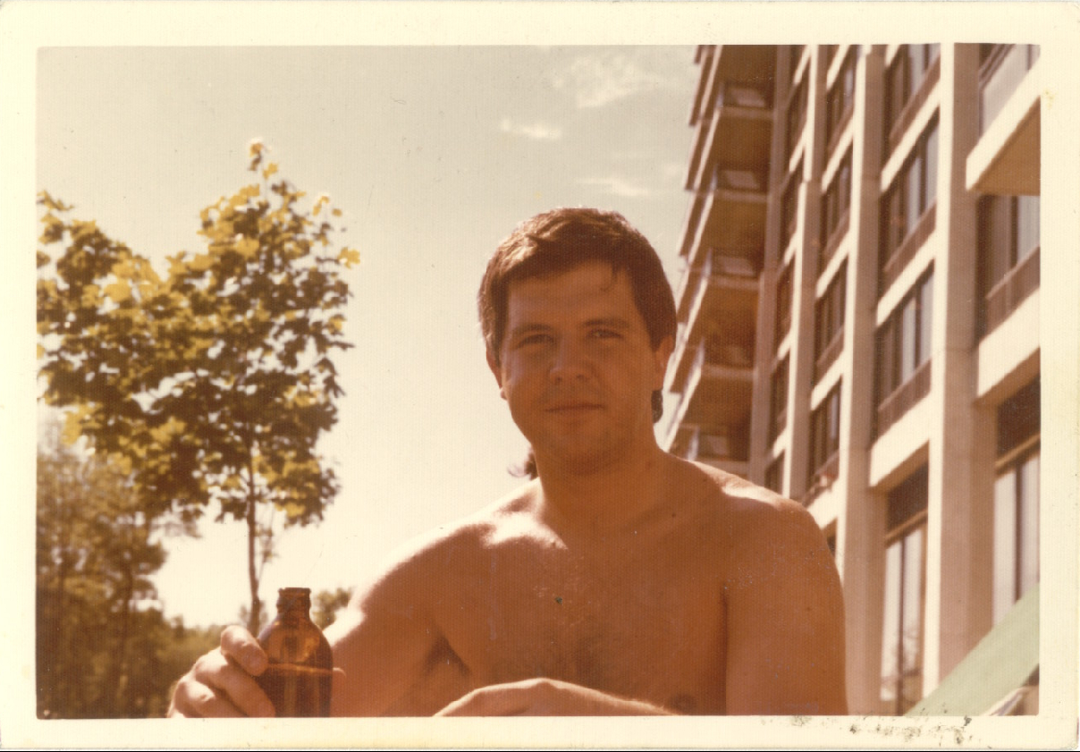
Me in 1988

